LIT_DAY10 - ASSIGNMENT

Name : Jalli Jyosthnavi

Emp.ID;- 46255252.

Batch: sap abap 25.

**Assignment 3 – Business Add in (BADI)-Single Use**

**Hint:**

1. **SE18 should be used to define a BADI**
2. **SE19 should be used to implement the BADI Definition.**

REPORT ZGMG_DEMO_BADI.  
  
PARAMETERS: NUM1 TYPE I,  
            NUM2 TYPE I.  
DATA RES TYPE I.  
DATA OBJ TYPE REF TO ZBADI_DEMO_132_INT.  
  
CALL METHOD CL_EXITHANDLER=>get_instance  
  EXPORTING  
    exit_name                     = 'ZBADI_DEMO_132_INT'  
  CHANGING  
    instance                      =   OBJ  
  .  
IF sy-subrc <> 0.  
  MESSAGE 'Error while calling method' TYPE 'I'.  
ENDIF.  
*CALL METHOD OBJ->divide  
*  EXPORTING  
*    i_num1      = NUM1  
*    i_num2      = NUM2  
*  IMPORTING  
*    e_result    = RES  
*  EXCEPTIONS  
*    div_by_null = 1  
*  .  
CALL METHOD OBJ->DIVIDENUMBERS  
  EXPORTING  
    I_NUM1    = NUM1  
    I_NUM2    = NUM2  
  IMPORTING  
    E_RESULT  = RES  
  EXCEPTIONS  
    NULLVALUE = 1  
    OTHERS    = 2  
  .  
IF SY-SUBRC <> 0.  
 MESSAGE ID SY-MSGID TYPE SY-MSGTY NUMBER SY-MSGNO  
            WITH SY-MSGV1 SY-MSGV2 SY-MSGV3 SY-MSGV4.  
ENDIF.  
IF sy-subrc = 1.  
  MESSAGE 'Division by zero' TYPE 'I'.  
ELSE.  
    WRITE:/ 'NUM 1 IS : ' , NUM1.  
    WRITE:/ 'NUM 2 IS : ' , NUM2.  
    WRITE:/ 'RESULT IS : ' , RES.  
ENDIF.

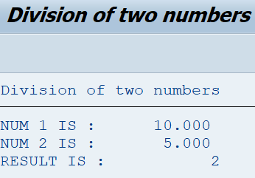

**Assignment 4 – Business Add in (BADI)-Multiple Use**

**Hint:**

1. **SE18 should be used to define a BADI**
2. **SE19 should be used to implement the BADI Definition.**

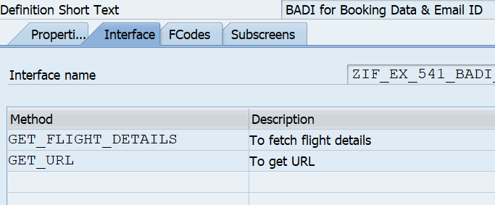

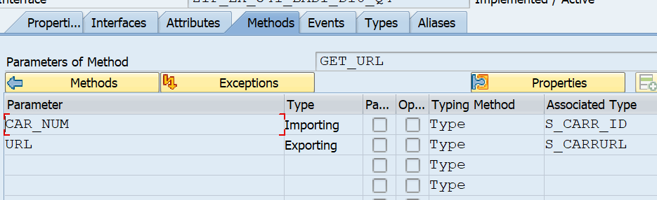

**PROGRAM**

REPORT ZGMG_BADI_Q4.  
  
DATA L_INF TYPE REF TO Z215_IF_DAY10_Q4.                      "Reference variable to the Interface  
  
PARAMETERS: P_CARRID TYPE S_CARR_ID,                                "Parameters for carrier number & Flight number  
            P_CONNID TYPE S_CONN_ID.  
  
DATA: IT_SFLIGHT TYPE TABLE OF ZGMG_BADI_TT.                   "Internal table for structure  
  
CALL METHOD CL_EXITHANDLER=>GET_INSTANCE                            "Calling Function module for the execution  
EXPORTING  
    EXIT_NAME                     = 'ZGMG_BADI_Q4'              "BADI Definition  
CHANGING  
    INSTANCE                      = L_INF                           "Interface instance  
EXCEPTIONS  
    NO_REFERENCE                  = 1  
    NO_INTERFACE_REFERENCE        = 2  
    NO_EXIT_INTERFACE             = 3  
    CLASS_NOT_IMPLEMENT_INTERFACE = 4  
    SINGLE_EXIT_MULTIPLY_ACTIVE   = 5  
    CAST_ERROR                    = 6  
    EXIT_NOT_EXISTING             = 7  
    DATA_INCONS_IN_EXIT_MANAGEM   = 8  
OTHERS                        = 9  
.  
IF SY-SUBRC <> 0.  
ENDIF.  
  
L_INF->GET_FLIGHT_DETAILS(                                                "Calling method for getting flight details using interface reference  
EXPORTING  
    CAR_NUM      =   P_CARRID  " Carrier Name  
    FLIGHT_NUM     =   P_CONNID  " Flight Number  
IMPORTING  
    FLIGHT_DETAILS =   IT_SFLIGHT " Table type for filght details - 538  
EXCEPTIONS  
OTHERS         = 2  
).  
IF SY-SUBRC <> 0.  
MESSAGE 'DATA NOT PROCESSED' TYPE 'E'.  
ENDIF.  
  
CL_DEMO_OUTPUT=>DISPLAY(                                                  "To display the table  
EXPORTING  
DATA =  IT_SFLIGHT   " Text or Data  
    NAME =  'Flight details'  
).  
  
L_INF->GET_URL(                                                           "Calling method to get url for given carrid  
EXPORTING  
    CAR_NUM =  P_CARRID   " Carrier Name  
IMPORTING  
    URL       =  DATA(URL)  " Airline URL  
).  
  
WRITE: 'URL IS:',URL COLOR 5.

